df2 = pd.read_csv('RSFHFSN.csv',index_col=0,parse_dates=True) # load the data

df2.head() # look at the first 5 rows and decide to plot the data. To see how it looks

DATE RSFHFSN

1992-01-01 3846.0

1992-02-01 3908.0

1992-03-01 4157.0

1992-04-01 4141.0

1992-05-01 4275.0

df2.plot()

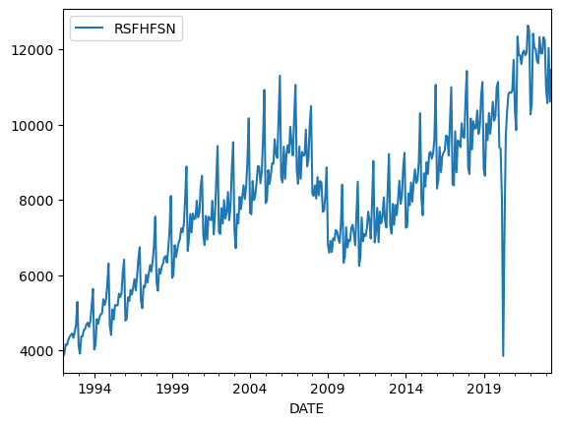

# import a package from stastmodels called adfuller to complete the Dickey-Fuller Method

# create a variable called rsfhfsn and called the adfuller packages along with my dataframe(df2)

from statsmodels.tsa.stattools import adfuller

rsfhfsn = adfuller(df2)

# Print the variable

print(rsfhfsn)

# Create Series to make the data look nice and organized

df_output1 = pd.Series(rsfhfsn[0:4],index=['Rsfhfsn ADF Test Statistics','p_value','# of lags','# of Obs'])

print(df_output1)

Rsfhfsn ADF Test Statistics -1.166635

p_value 0.687781

# of lags 14.000000

# of Obs 362.000000

dtype: float64

# As you see we have p-value of 0.69. A significant level that is always good to test for is 0.05. If my p-value is < 0.05 then it is not stationary. My p-value is 0.69 so, this concludes that my p-value is greater than 0.05. We are stationary based on our test